Chatbot using AI
Chatbot
Chatbot is a software application used to conduct online chat in text or text-to-speech, instead of providing direct contact with a live person. Designed to mimic the way a person behaves as a chat partner, chatbot systems often require continuous tuning and testing, and many in production remain unable to adequately chat or pass a standard Turing field test. The term "ChatterBot" was originally coined by Michael Mauldin (developer of the first Verbot) in 1994 to describe these chat systems.
Chatbots are used in inbox applications for a variety of purposes including customer service, route request, or data collection. While some chatbot applications use a wide range of word processing, natural language processors, and sophisticated AI, others simply scan common keywords and generate responses using standard phrases found in the corresponding library or database.
Pre-requisites
- Tensorflow- TensorFlow is a free and open-source software library for dataflow and differentiable programming across a range of tasks. It is a symbolic math library, and is also used for machine learning applications such as neural networks.
- Keras- Keras is an open-source library that provides a Python interface for artificial neural networks. Keras acts as an interface for the TensorFlow.
- Pickle- The pickle module implements binary protocols for serializing and de-serializing a Python object structure.
- NLTK- The Natural Language Toolkit, or more commonly NLTK, is a suite of libraries and programs for symbolic and statistical natural language processing (NLP) for English written in the Python programming language.
- Tkinter- For GUI based chatting applications.
Natural Language Processing
Natural language processing (NLP) is a subfield of linguistics, computer science, and artificial intelligence concerned with the interactions between computers and human language, in particular how to program computers to process and analyze large amounts of natural language data.

Common NLP Tasks-
- Text and speech processing
- Morphological analysis
- Syntactic analysis
- Lexical semantics
- Relational semantics
- Discourse
Task Used - Morphological Analysis
Morphological Analysis
- Lemmatization - The task of removing inflectional endings only and to return the base dictionary form of a word which is also known as a lemma.
- Morphological Segmentation - Separate words into individual morphemes and identify the class of the morphemes. The difficulty of this task depends greatly on the complexity of the morphology (i.e., the structure of words) of the language being considered. English has fairly simple morphology, especially inflectional morphology, and thus it is often possible to ignore this task entirely and simply model all possible forms of a word (e.g., "open, opens, opened, opening") as separate words.
- Part-of-speech tagging - Given a sentence, determine the part of speech (POS) for each word. Many words, especially common ones, can serve as multiple parts of speech. For example, "book" can be a noun or verb."Set" can be a noun, verb or adjective; and "out" can be any of at least five different parts of speech. Some languages have more such ambiguity than others. Languages with little inflectional morphology, such as English, are particularly prone to such ambiguity. Chinese is prone to such ambiguity because it is a tonal language during verbalization.
- Stemming - The process of reducing inflected (or sometimes derived) words to their root form. (e.g., "close" will be the root for "closed", "closing", "close", "closer" etc.).

Steps for making the project -
Chatbot.ipynb
- Import and load the data file – Import the libraries keras, tenorflow, pickle and nltk and data from intents.json
- Preprocess the data – Tokenize the text data. Break the word text in small parts like word and append each word in words list to create a list of classes for our text. Then after that lemmatize each word and remove duplicates. Then create a pickle file for using during prediction.
- Creating training and testing data – Provide input as pattern and ouptut as class which input pattern belongs to fot training. But converting the text into numbers so that machine can understand it.
- Building the model – Build the model using three layers, using keras Sequential model and for 200 epochs we achieve 100% accuracy. (may vary from intents.json)
Chat_gui.py
- Predict the response – Predict the resposne by running chat_gui.py file and chatting in the gui window for response.
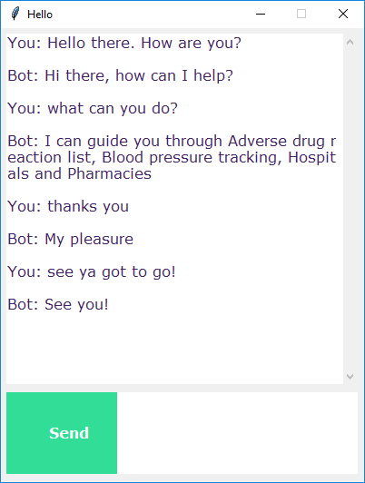

Applications of Chatbot
- Messaging apps – Many companies' chatbots run on messaging apps or simply via SMS.
- Customer Services – Many high-tech banking organizations are looking to integrate automated AI-based solutions such as chatbots into their customer service in order to provide faster and cheaper assistance to their clients who are becoming increasingly comfortable with technology. In particular, chatbots can efficiently conduct a dialogue, usually replacing other communication tools such as email, phone, or SMS. In banking, their major application is related to quick customer service answering common requests, as well as transactional support.
- Assistants – Amazons Alexa, Google assitant are a great example of chatbot based applications which have a horizon of possibilities from automating general household tasks to automating home itself.
Limitations of Chatbot
- As the database, used for output generation, is fixed and limited, chatbots can fail while dealing with an unsaved query.
- A chatbot's efficiency highly depends on language processing and is limited because of irregularities, such as accents and mistakes.
- Chatbots are unable to deal with multiple questions at the same time and so conversation opportunities are limited.
- Chatbots require a large amount of conversational data to train.
- Chatbots have difficulty managing non-linear conversations that must go back and forth on a topic with a user

